



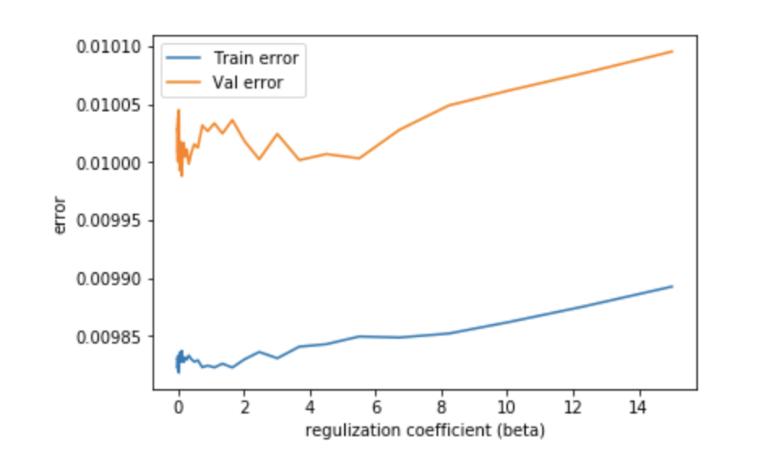



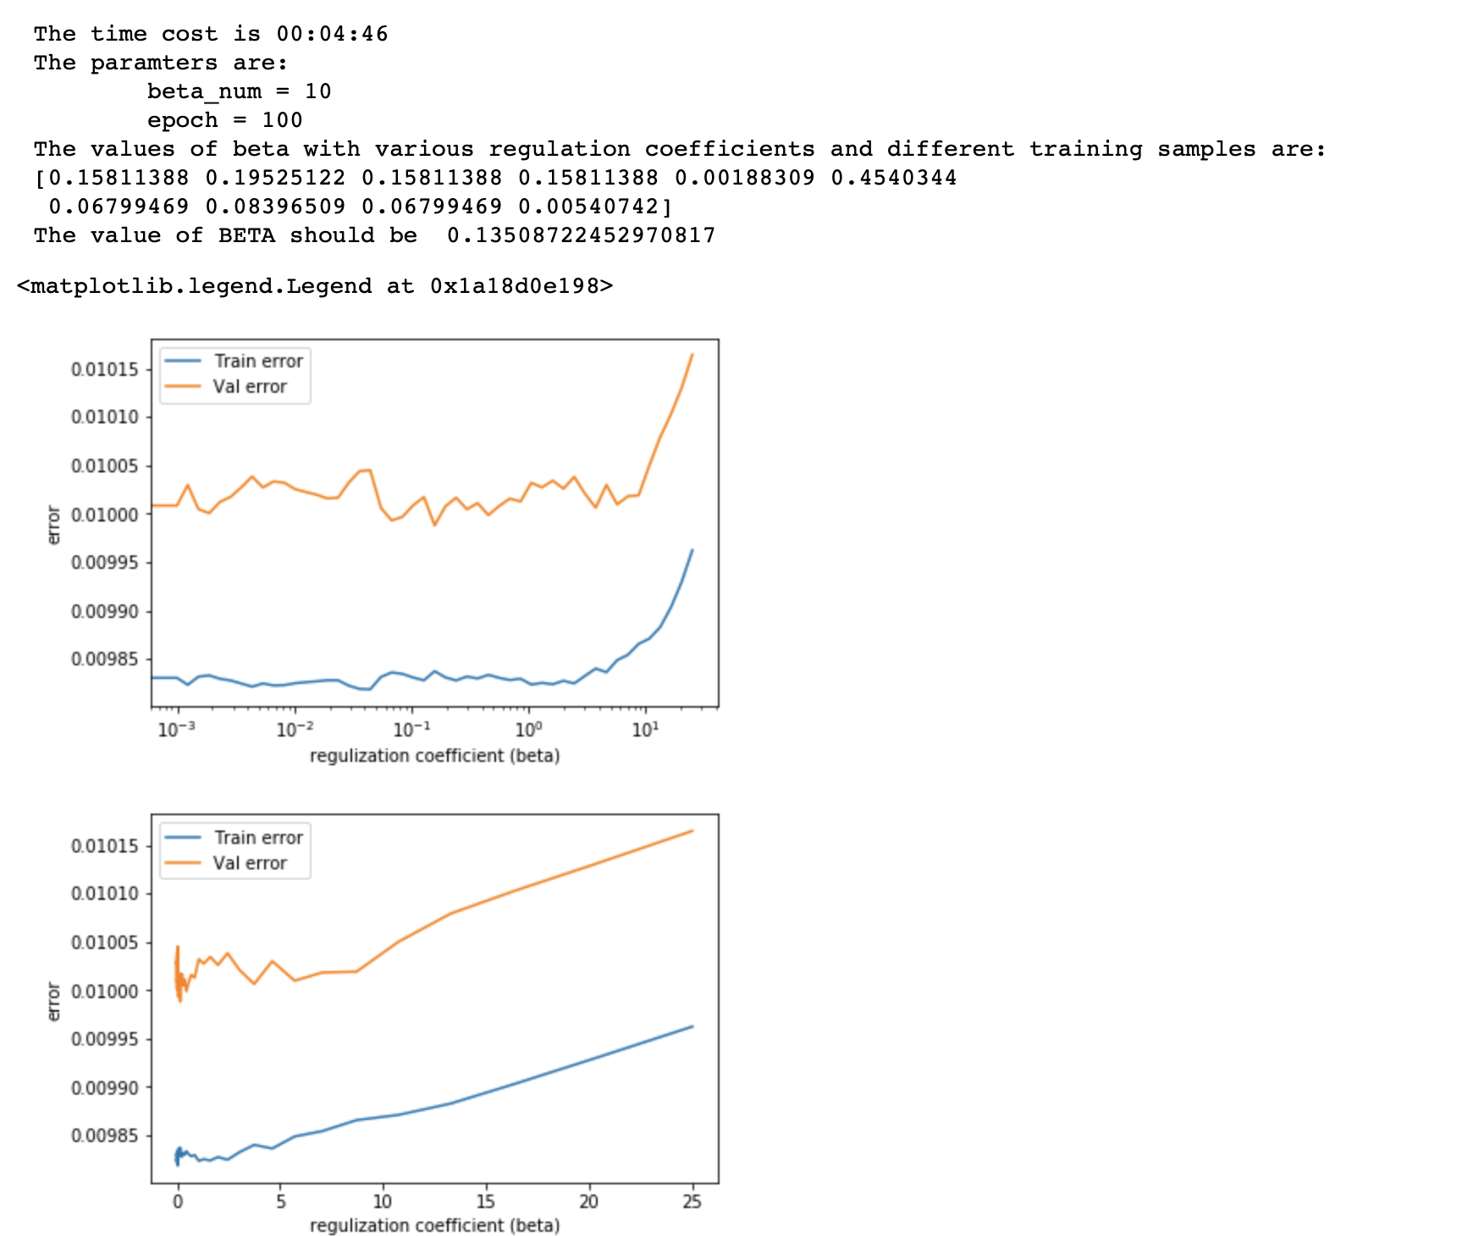

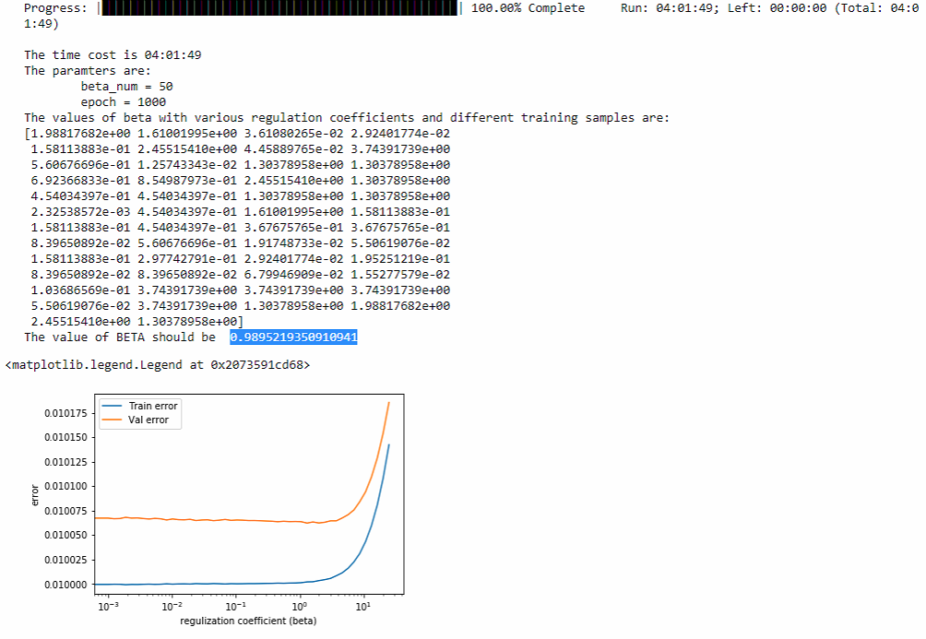

Progress: |██████████████████████████████████████████████████| 100.00% Complete Run: 04:01:49; Left: 00:00:00 (Total: 04:01:49)

The time cost is 04:01:49

The paramters are:

beta_num = 50

epoch = 1000

The values of beta with various regulation coefficients and different training samples are:

[1.98817682e+00 1.61001995e+00 3.61080265e-02 2.92401774e-02

1.58113883e-01 2.45515410e+00 4.45889765e-02 3.74391739e+00

5.60676696e-01 1.25743343e-02 1.30378958e+00 1.30378958e+00

6.92366833e-01 8.54987973e-01 2.45515410e+00 1.30378958e+00

4.54034397e-01 4.54034397e-01 1.30378958e+00 1.30378958e+00

2.32538572e-03 4.54034397e-01 1.61001995e+00 1.58113883e-01

1.58113883e-01 4.54034397e-01 3.67675765e-01 3.67675765e-01

8.39650892e-02 5.60676696e-01 1.91748733e-02 5.50619076e-02

1.58113883e-01 2.97742791e-01 2.92401774e-02 1.95251219e-01

8.39650892e-02 8.39650892e-02 6.79946909e-02 1.55277579e-02

1.03686569e-01 3.74391739e+00 3.74391739e+00 3.74391739e+00

5.50619076e-02 3.74391739e+00 1.30378958e+00 1.98817682e+00

2.45515410e+00 1.30378958e+00]

The value of BETA should be 0.9895219350910941